A
Project Report On
Footwear Shop
Inventory Management System
Submitted in partial fulfillment of the requirements for the award of degree
Bachelor of Computer Application Final Year
From
Pt. Ravishankar Shukla University Raipur (C.G.)

Year : 2023-24

Guide Submitted by:
Dr. VARSHA THAKUR ATUL VERMA
Roll No: 4309

Submitted to
Government Nagarjuna Post Graduate College of Science, Raipur
Pt. Ravishankar Shukla University Raipur (C.G.)
- Certificate of Approval by Head of the Department.

CERTIFICATE OF APPROVAL
This is to certify that the Project work entitled “Footwear Shop Inventory Management System” is carried out by Mr. ATUL VERMA, a student of BCA – III year at Government Nagarjuna Post Graduate College of Science, Raipur is hereby approved as a credible work in the discipline of Computer Science & Information Technology for the award of degree of Bachelor of Computer Application during the year 2023-24 from Pt. Ravishankar Shukla University, Raipur (CG).

DR. KIRAN BALA DUBEY
(Head of the Department)

2. Certificate from the Guide.

CERTIFICATE
This is to certify that the Project work entitled “Footwear Shop Inventory Management System” Submitted to the Government Nagarjuna Post Graduate College of Science, Raipur by Mr. ATUL VERMA Roll No 4309, in partial fulfillment for the requirements relating to nature and standard of the award of Bachelor of Computer Application degree by, Pt. Ravishankar Shukla University, Raipur (CG) for the academic year 2023 - 2024.
This project work has been carried out under my guidance.

DR. VARSHA THAKUR
(Guide Name)

3. Certificate of evaluation.

CERTIFICATE OF EVALUATION

This is to certify that the Project work entitled “Footwear Shop Inventory Management System” is carried out by Mr. ATUL VERMA, a student of BCA – III year at Government Nagarjuna Post Graduate College of Science, Raipur, after proper evaluation and examination, is hereby approved as a credible work in the discipline of Computer Science & Information Technology and is done in a satisfactory manner for its acceptance as a requisite for the award of degree of Bachelor of Computer Application during the year 2023-24 from Pt. Ravishankar Shukla University, Raipur (CG).

Internal Examiner External Examiner

3. Declaration of Student / Self Certificate

DECLARATION

This to certify that the project report entitled “Footwear Shop Inventory Management System”, which is submitted by me in the partial fulfillment for the award of the degree of Bachelor of Computer Application, Government Nagarjuna Post Graduate College of Science, Raipur, comprises the original work carried out by me.
I further declare that the work reported in this project has not been submitted and will not be submitted, either in part or in full for the award of any other degree or diploma in this Institute or any other Institute or University.

Place: Raipur C.G. ATUL VERMA
Date: Roll No 4309

Table of Contents

1. Introduction
1.1 Purpose of this report
1.2 Scope of “Footwear Shop Inventory Management System”
2. Specific Requirements
2.1 Functional Requirements
2.2 Nonfunctional Requirements
2.3 External Interface Requirements
3. Data Flow Diagram
3.1 Notations used
3.2 Level 0 DFD
3.3 Level 1 DFD
3.4 Level 2 DFD
4. Entity Relationship Diagram
4.1 Notations used
4.2 Diagram
5. Project Screen Shots
6. future inhansment
7. source code

1 Introduction
“Footwear Shop Inventory Management System” app is a software application that helps a footwear shop owner to manage inventory and create bills (for customers). This application also gives report such as monthly profit and soled product count etc.
1.1 Purpose of this Report
The purpose of the document is to give an overview of “Footwear Shop Inventory Management System” application and helps understanding how the app actually works, Flow of data in application and its requirement. This document includes all the technical data required for use and future enhancements.
1.2 Scope of “Footwear Shop Inventory Management System”
This app solves the problem of maintaining records on pen and paper and replace it with digit counterpart. This is also a billing application for generating customer bills. This software also gives monthly reports on profit and loss and sold products in just one click.

2 Specific Requirements
2.1 Functional Requirements
For Operator :-
- Brief Description
An Operator can add product and its units available and when a customer purchase products operator also generates bills.
- Initial Step-By-Step Description
1) First operator login with there login id and
2.2 Nonfunctional Requirements
The software uses the local machine to compute all operations. The app uses oracle database running at the local machine as localhost to store the all information

2.3 External Interface Requirements
Software Requirements:
- This software only works on windows pc with windows version 10 and above.
(Tested on windows 10 and 11)
- For this app to work Oracle database 10g XE and Microsoft Dot Net Core 6 (long term support) must be installed in the system.

HardWare Requirements:

- At leat 15Mb of secondary storage is required. (Oracle Database and Dot Net 6 take sotrage separately.)
- At least 15Mb of free RAM is required for. (Oracle Database and Dot Net 6 take RAM separately.)

3. Data Flow Diagram
3.1 Notations used

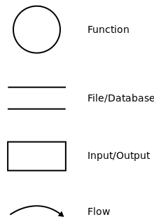

Leverl 0 Data Flow Diagram

Leverl 1 Data Flow Diagram

4. Entity Relationship Diagram
4.1 Notations used
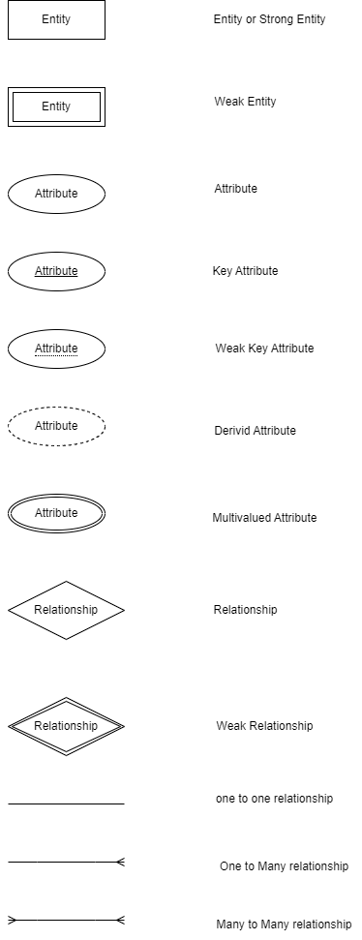

4.2 Diagram

